**REF: Project for sustainable Water, Sanitation, Hygiene, and Agriculture Programm in Pageri Payam Magwi County, Eastern Equatoria State, South Sudan**

**Project No: *2015.1542.8***

**Introduction:**

Bengo/IAS German signed an agreement with Community Action Water Programm and

Edooss on the 19th June 2015 for the project forSustainable Water, sanitation, hygiene,

and agriculture in Pageri Payam Magwi County, Eastern Equatoria State, South Sudan

**Project purpose**

The goal of the project is to improve the livelihood of the people of Pageri payam by provision of safe drinking water, promotion of hygiene and sanitation; and knowledge on improved agriculture. Its specific objectives are:

(i) improve access to safe water.

(ii) Improve community wide hygiene and sanitation practices

(iii) Increased and sustained food production in the primary school and community at large.

**Implementation strategic**

***Drilling and construction of boreholes***

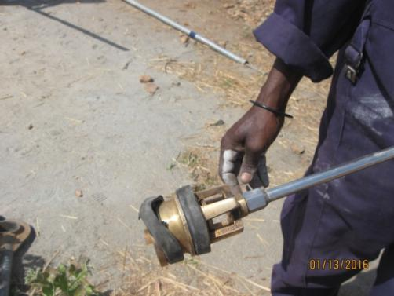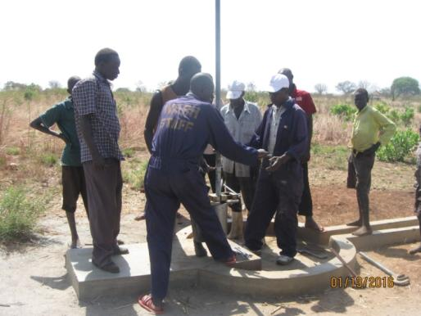***Oroba primary school borehole had developed some minior fault witht pistol rubber as shown on the photo.it has prompted CAWP to do a minor repair.***

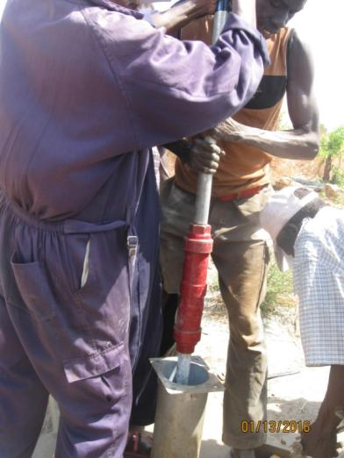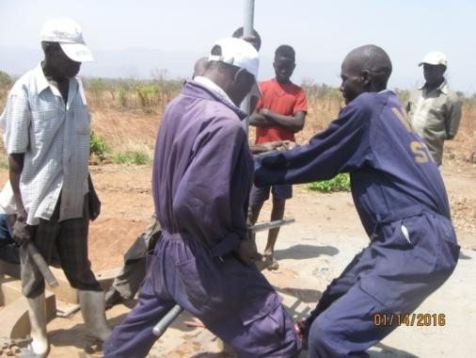

***CAWP crew are restalling the borehole pipes which the pistol has being repaired***

***This kind of fault do happened special when pump are not being tightened well right from the factory. Once pump into the well can resulted into not pumping water.***

***Bio-sandfilter construction and distribution***

*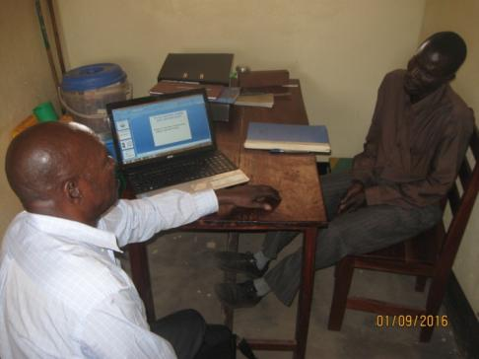The bio-sand work started by EDOOSS director conducting a short training for the Pageri water department staff as they had earlier expressed lack of knowledge about a bio-sand filter. The staff were taken through the purpose of a filter, what a filter is, its parts, how the filter works, how the is maintained, how the filter purifies water, the design parameters, filter effectiveness, how drinking water is linked to human health, pathogens in water and how filter removes them.*

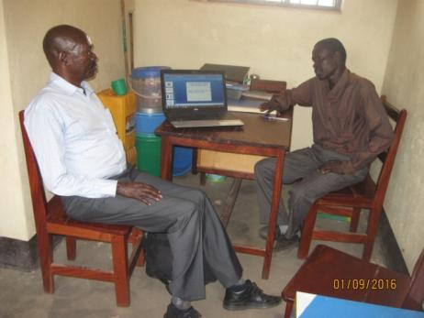

*After the training, an assessment was carried out to identify the exact beneficiaries. The beneficiaries are people who have no access to boreholes but drink water directly from rivers, springs and wells. They were identified along the banks of river Achwa and Atipi river all in Pageri payam the project area.*

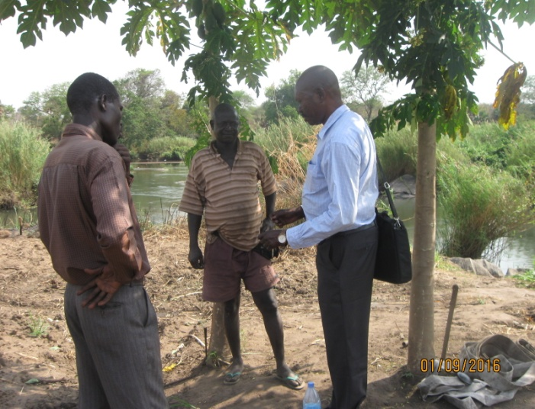

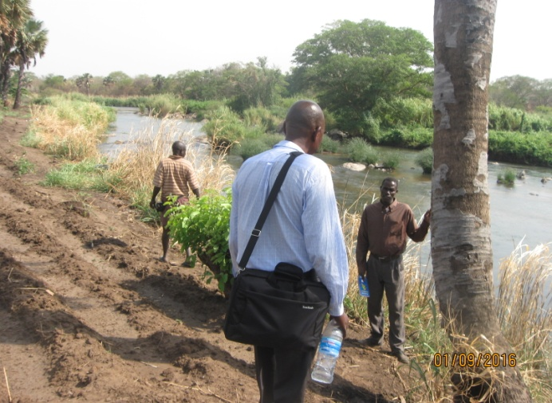

*The moulds are already on site, the bio-sand filter staff are collecting other materials in preparation for the construction.*

***School garden (vegetable gardens)***

*Meetings comprising teachers, parents and P.T.A were conducted in each of the four schools (Kerepi Primary, Kerepi Child Hope, Royal Kids and Orobe) in preparation for the garden work. In the meetings, parents and P.T.A promised to participate actively in the garden work. The agriculture department in Pageri and farmer groups accepted to give advisory roles and supervision to the schools in order to realize high yields of crops. Preparation of the vegetable gardens startrd in February 2016.*

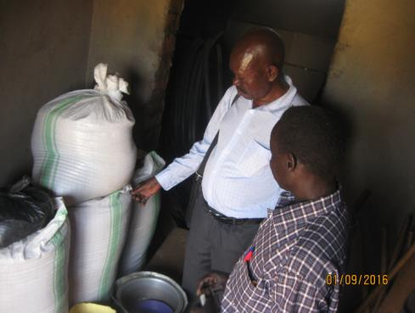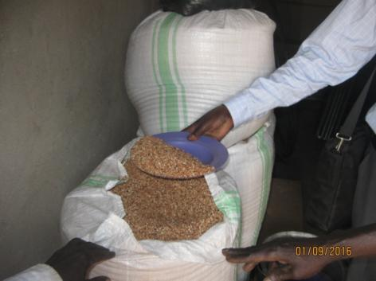

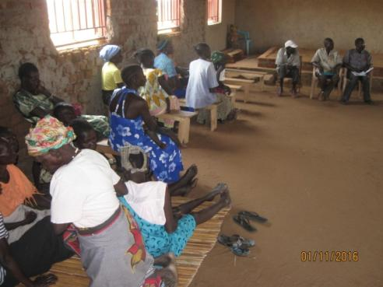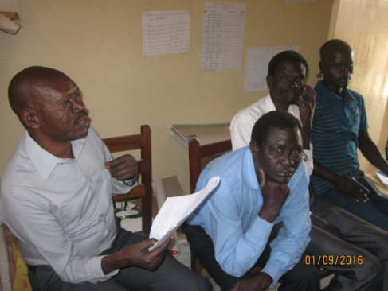

***Others***

*Orobe Primary school wanted to start preparing lunch for the school children at the start of first term 2016 but lacked sausefans for cooking. As the school is one of the most needy among the four schools, EDOOSS bought for them two large sausefans for cooking.*

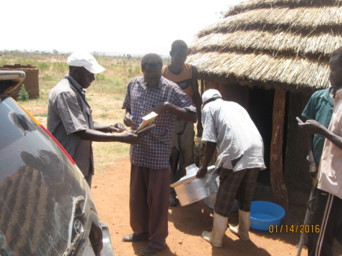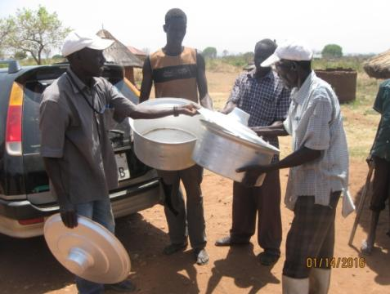

***Comments***

*CAWP and EDOOSS are so much encouraged by the level of participation of the government authorities and the local community leaders. The project has ushered in team spirit among community members.*

***Challenges:***

* *Inflation has continued to rise*
* *It is very hard to operate the hard currency accounts in South Sudan*
* *Delay in the formation of the government of national unity as such standard of living and daily expense in Juba town ane other area become very expensive.*
* *Purchases of drilling spare parts from outside the country is delaying driling of the two reminiding boreholes in the two schools.*

***Possible solutions***

* *Some materials are being purchased from outside South Sudan*
* *CAWP is helping to use their dollar account in Uganda*
* *International community are puting presure on the both parties to speed up the formation of the unity government for peace to preveil inthe country.*
* *Management are doing their best to get the spare part so quick as possible.*